**Reg. No. 21BCE1297 Name: Vidhi Shah Date of Practical: 09/03/22**

**Experiment 3**

**Aim:**

Working and simulation of Half Wave Rectifier and Full Wave Rectifier.

**Tools and Apparatus:**

­LTSpice, Capacitor, Resistor, Diodes, Voltage Source

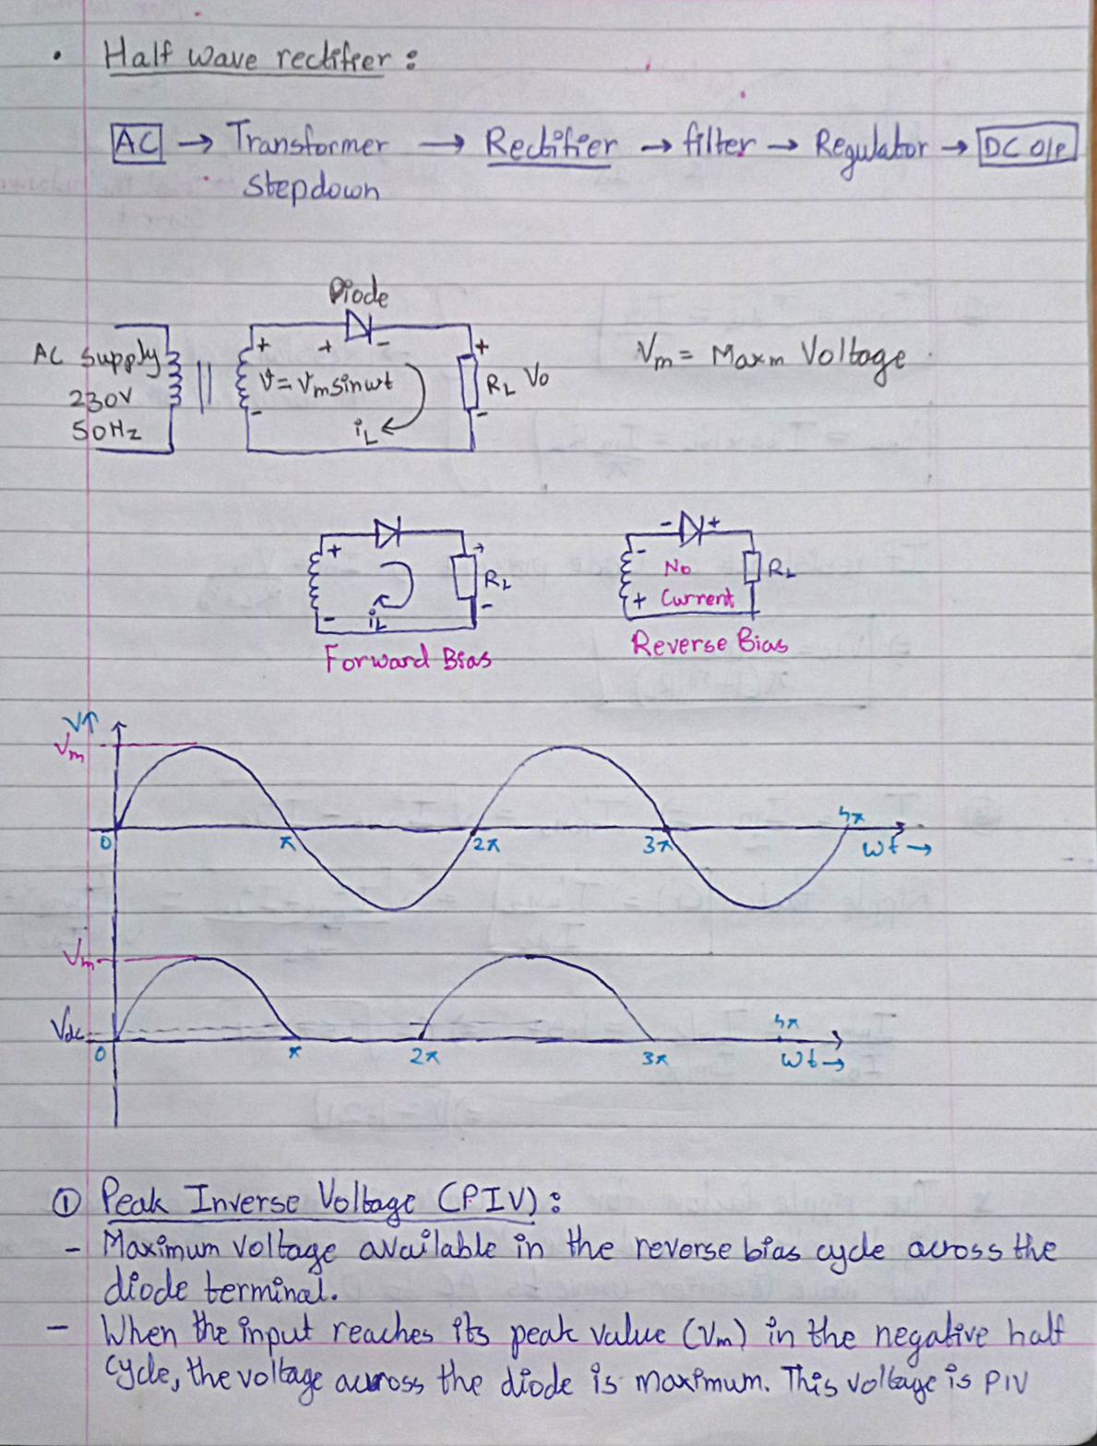**Theory and Design:**

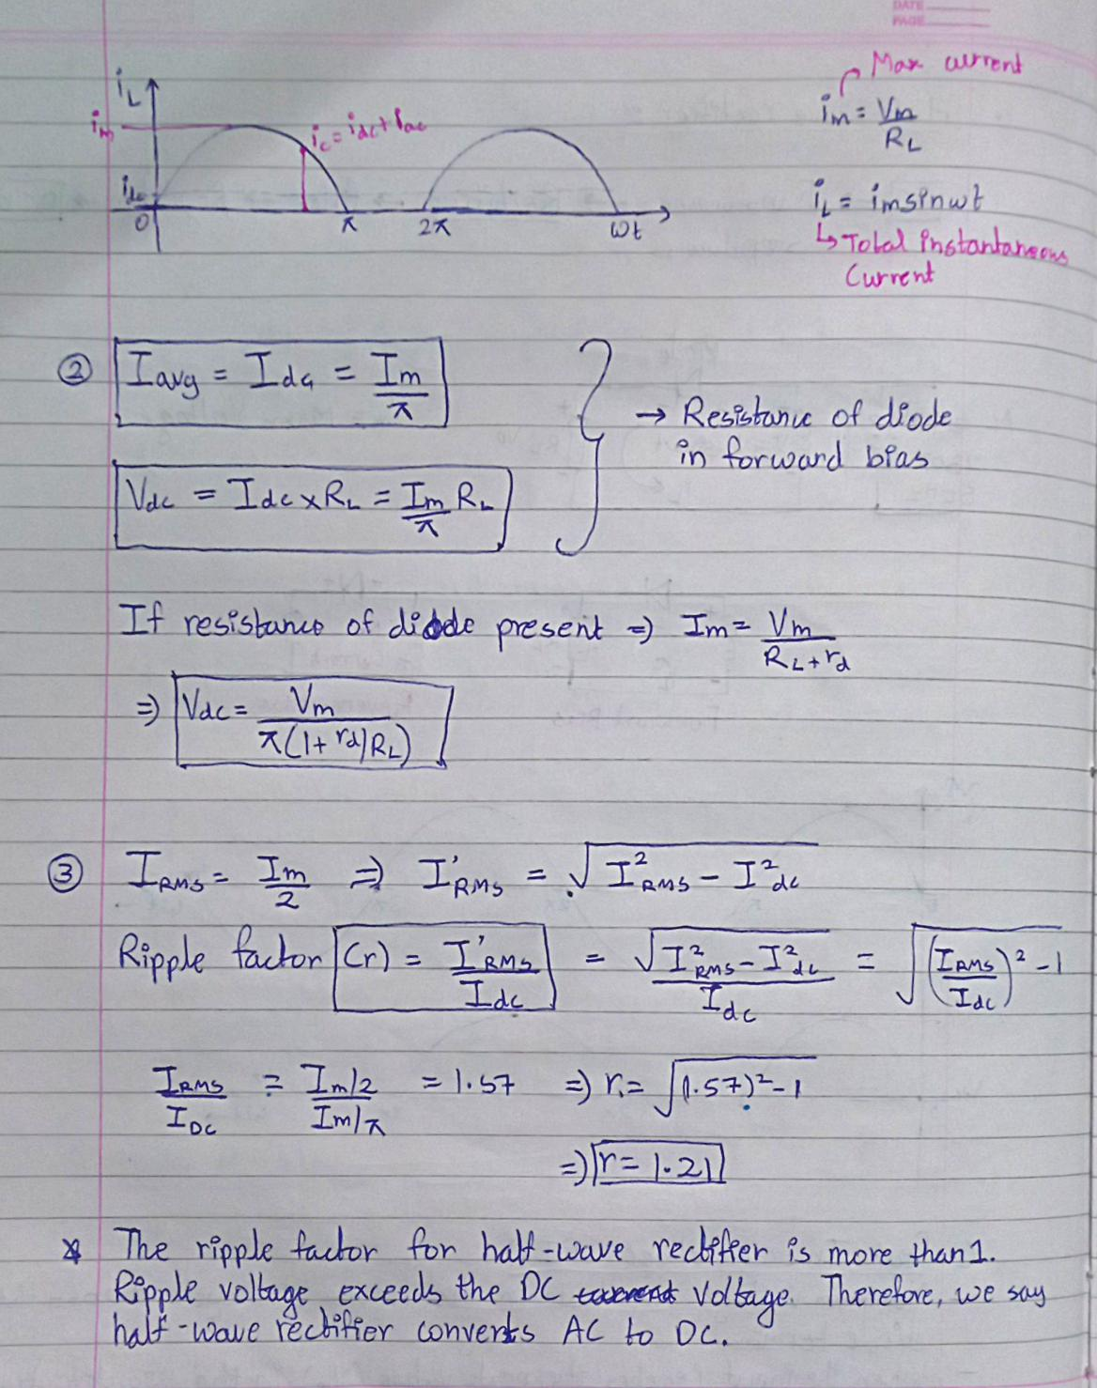

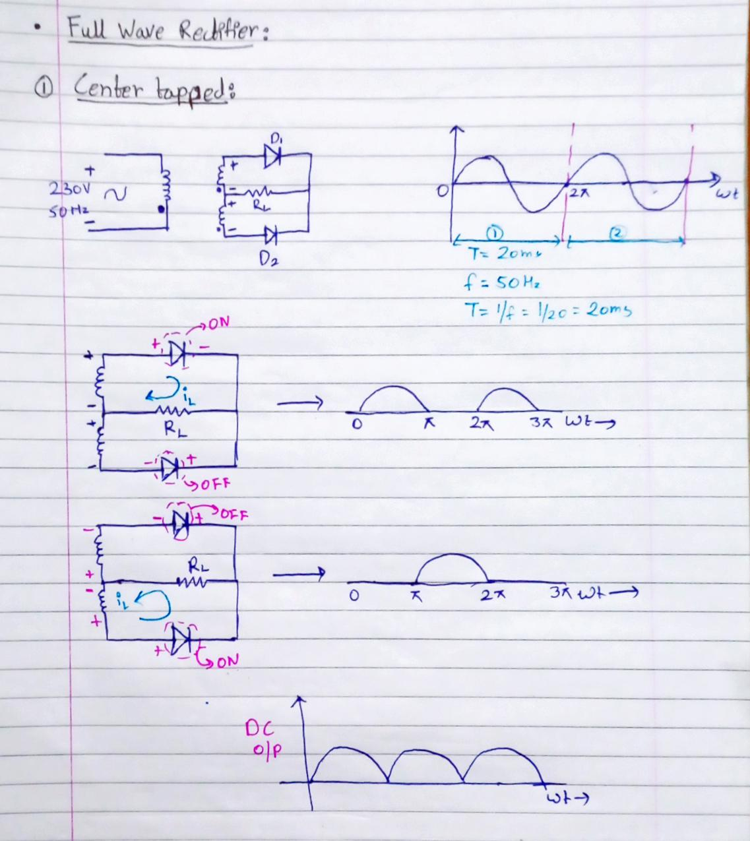

**Simulation Results:**

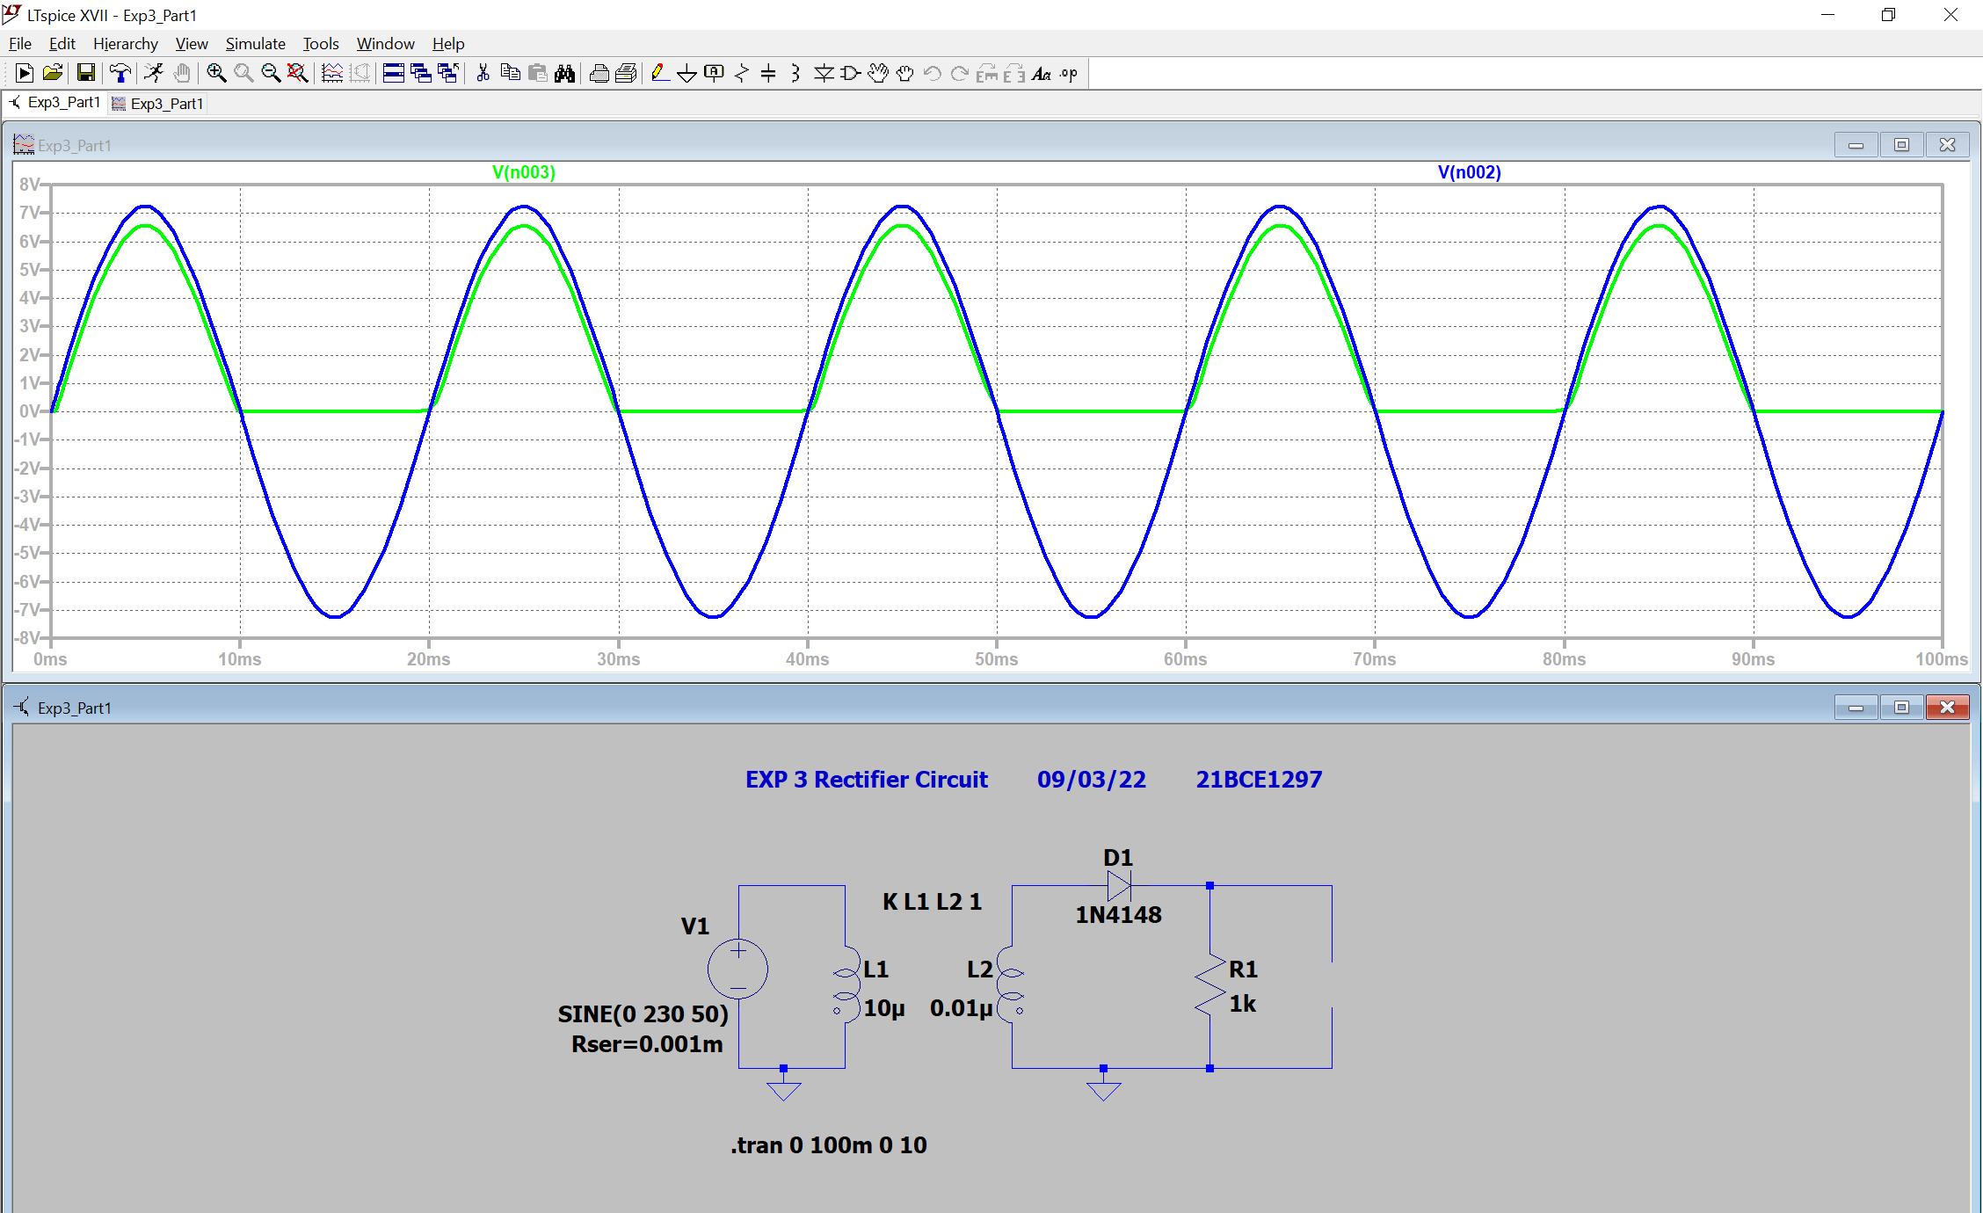**1)** **Half Wave Rectifier without capacitor**

**2)** **Half Wave Rectifier**

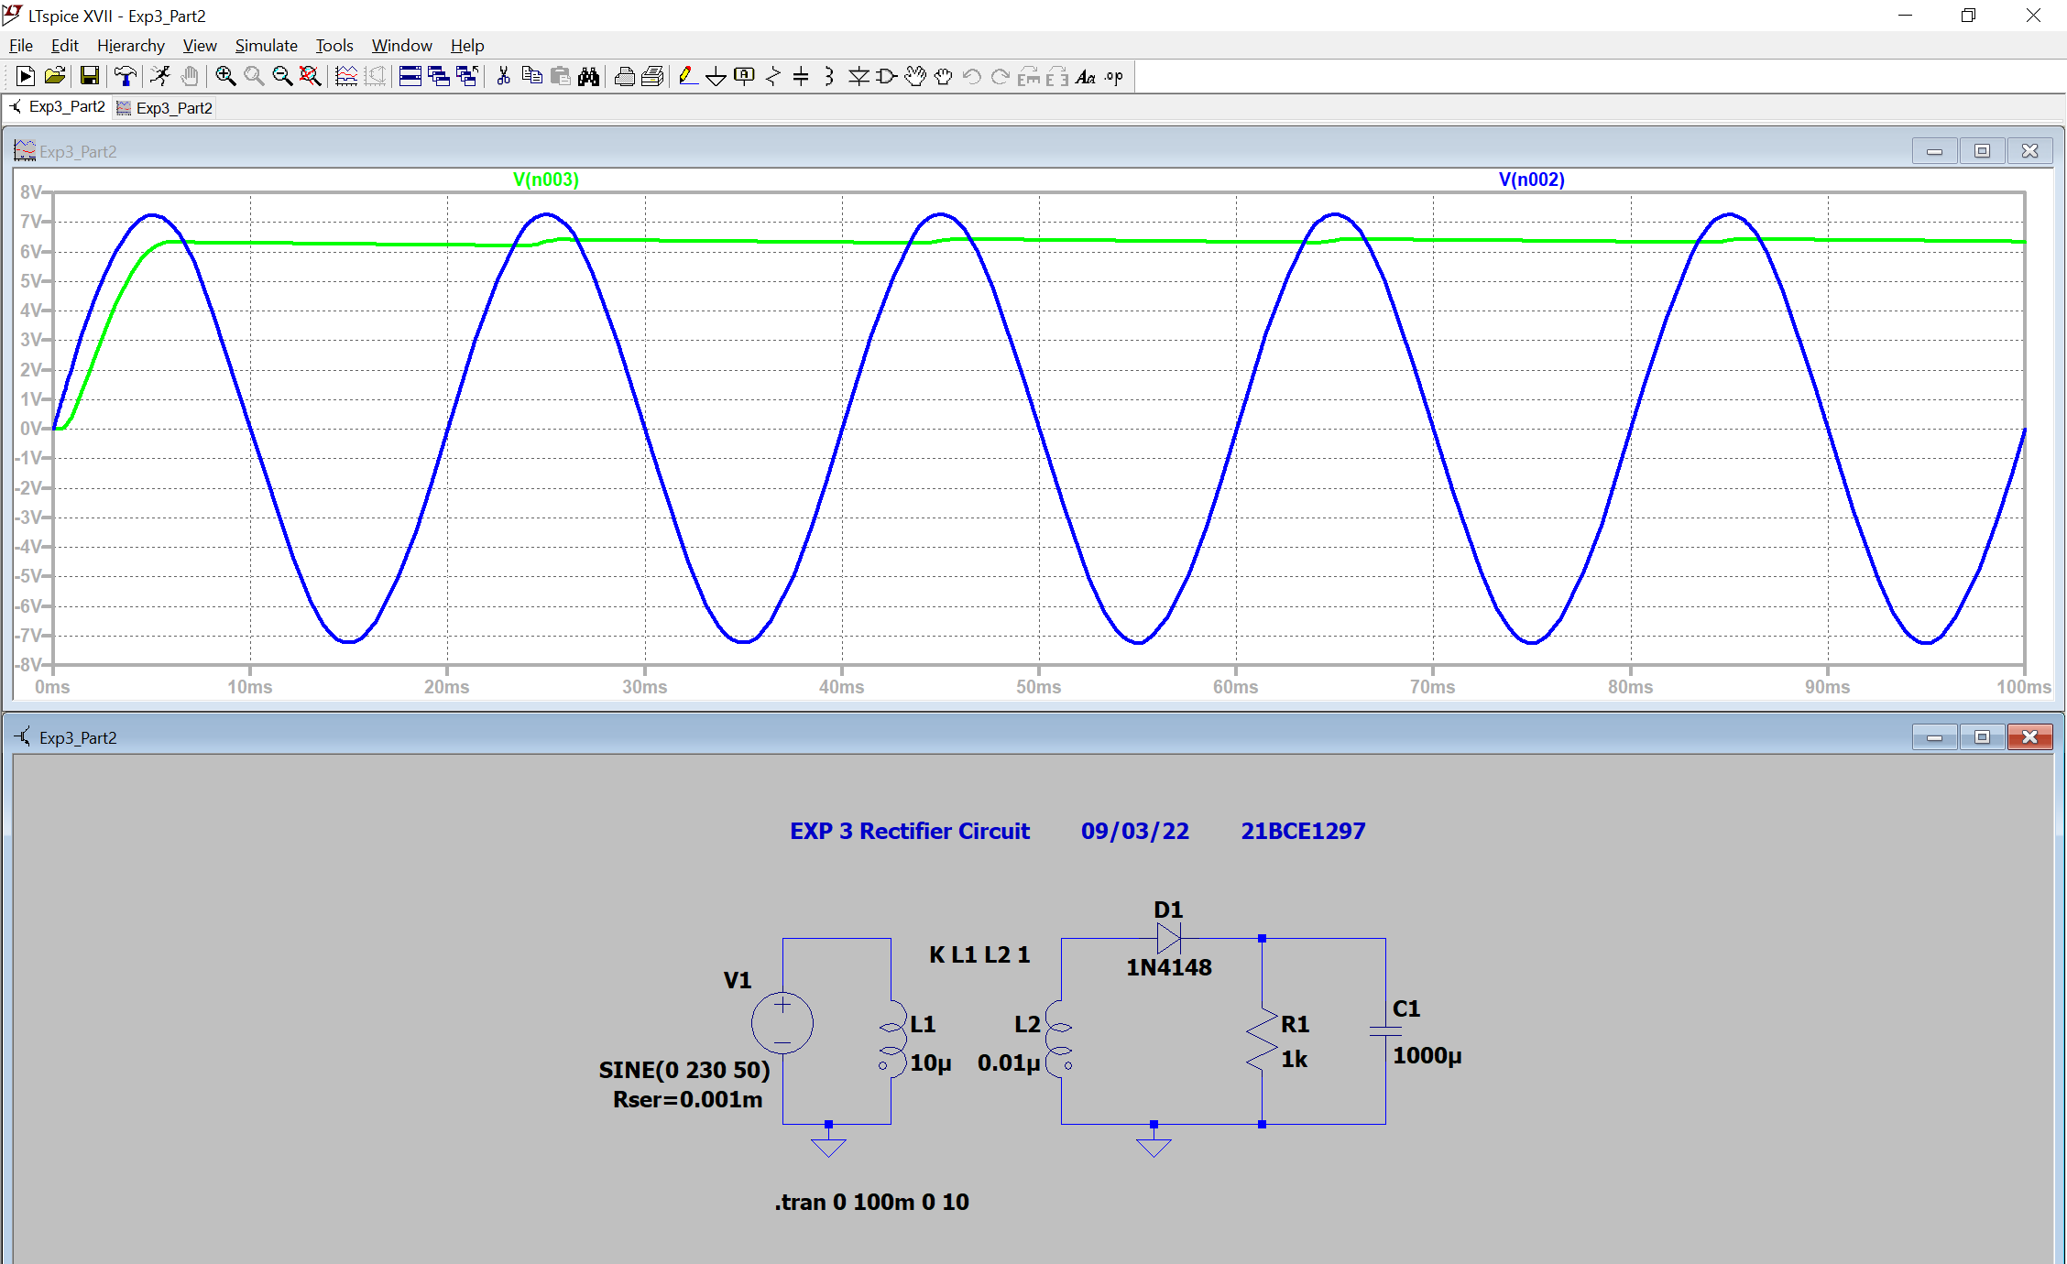 a) R = 1k Ω, C = 1000µ

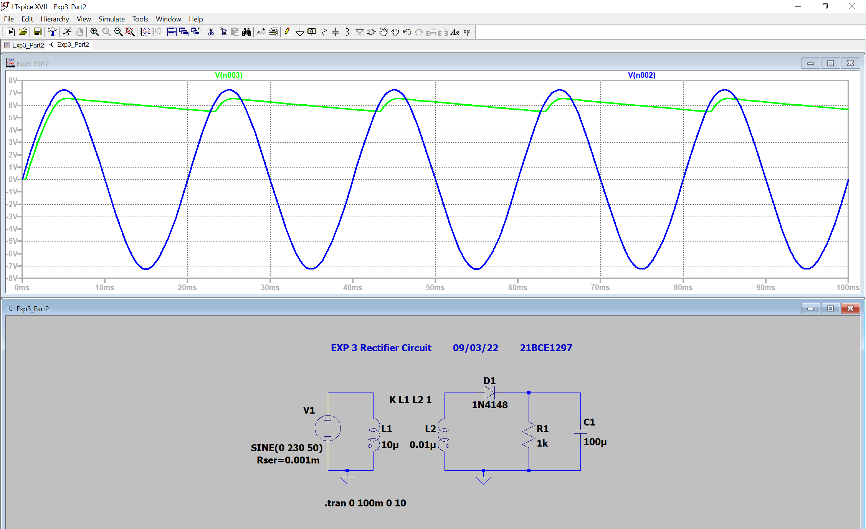b) R = 1k Ω, C = 100µ

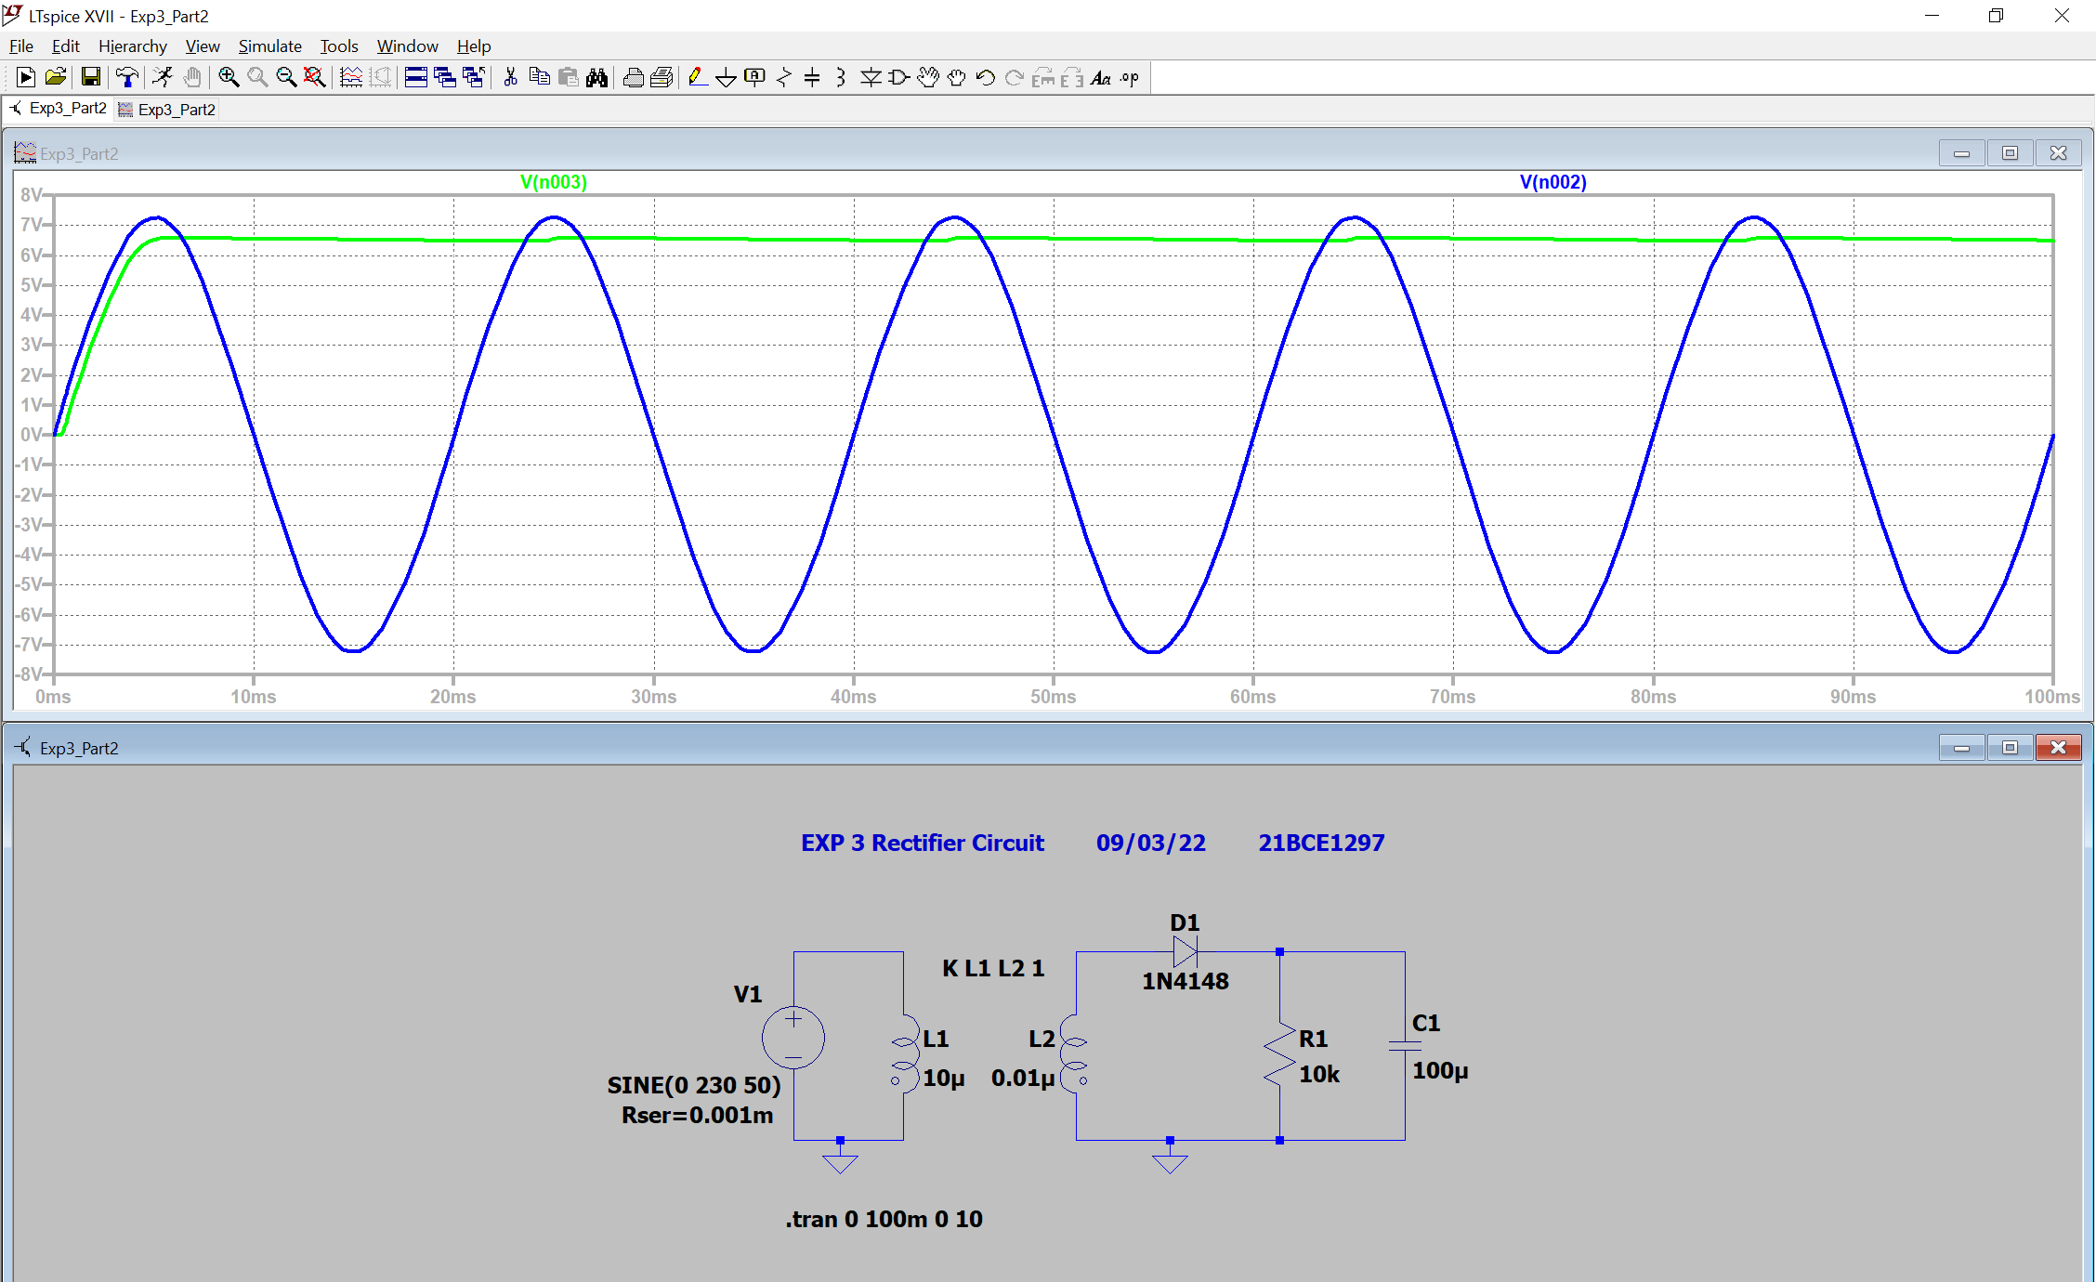c) R = 10k Ω, C = 100µ

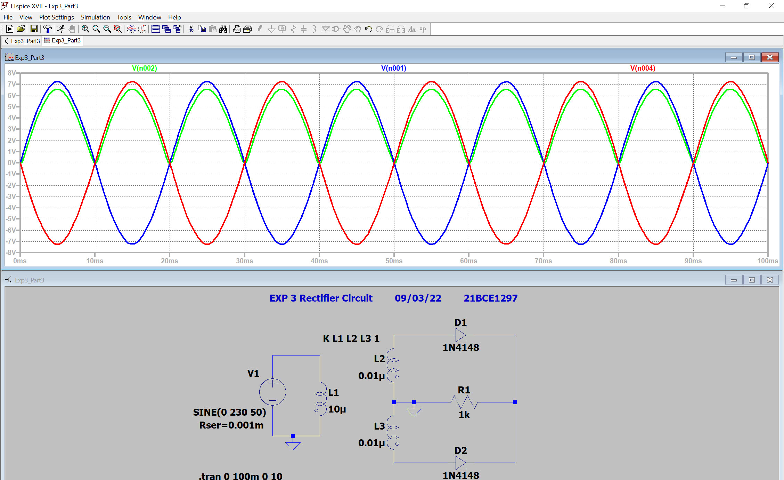**3)** **Full Wave Center Tapped Rectifier**

**Conclusion:**

1. **Cutting Voltage** for **Half Wave Rectifier** = 7.25 – 6.58 = **0.67 V**
2. **Cutting Voltage** for **Full Wave Rectifier** = 7.23 – 6.55 = **0.68 V**

**Inferences:**

1. Rectifiers are used to convert AC voltage to DC Voltage
2. Transformers are used for stepping down AC voltage
3. While stimulation connect diode in proper direction
4. Changing R and C values in half wave rectifier affects the DC output wave form
5. Difference between voltages gives cutting voltage which is approximately 0.7 for silicon diodes.